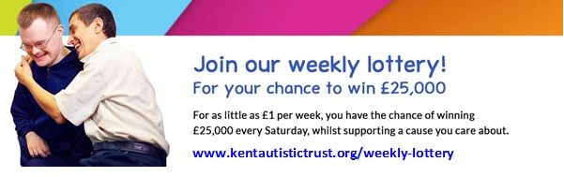

KENT AUTISM ALERT CARD
Application Form

Cardholder Details:
Name: ______________________________________________________________
Address: ______________________________________________________________
___________________________________________________________________________
Postcode: ________________________________

First Contact Details:
Name: ______________________________________________________________
Phone Number (One only): _____________________________________________________

Second Contact Details:
Name: ______________________________________________________________
Phone Number (One only): _____________________________________________________
*PLEASE REMEMBER TO ENCLOSE EVIDENCE AS STATED ON REVERSE*

Kent Autism Alert Card
Dear Sir/Madam,
Thank you for your interest in obtaining the Kent Autism Alert Card.
Please complete the details overleaf giving your details and the contact details of the person(s) you would like to be contacted in an emergency. Please note only one card can be issued per applicant.
The card has space for only 2 contact phone numbers. You might choose to name the same person as both contacts using a landline and mobile phone number or two people as contacts each having only one number (landline or mobile).
Please also enclose proof of the applicant having an Autistic diagnosis. This proof could be a copy of: The diagnosis letter, Letter from a professional (psychologist, doctor, or paediatrician), Medical report/assessment or a Headed letter/appointment letter from health or education – showing the applicants name and their diagnosis. Without this, the application will not be processed. Please send the application and diagnosis evidence to fsadmin@kentautistic.com

Please allow up to 12 weeks for the card to be processed. Once processed, the card will be addressed to the Cardholder. When you apply for an Autism Alert Card we will keep a record of your name and postcode to enable us to keep track of the number of applicants and general locations for grants and funding. There is a privacy statement on our website at https://www.kentautistic.com/what-we-do/family-support-services/ which explains how we manage your personal information. You can contact us at any time to let us know if your details change, or if you no longer want us to keep your personal information.
If you need to reapply due to lost cards or change of detail we would need to ask for a donation of £5 and for the application form to be completed again, you will not need to send evidence of a diagnosis at this time.
If you would like to make a small donation to cover the cost of the making of the card, we would be very grateful. You can do this either by bringing cash in to our office or by BACS payment using Family Support's bank details: Sort code 20-54-11, Account No. 13995194
Please return this completed form, and proof to fsadmin@kentautistic.com.
Kind regards,

Family Support Admin.
Kent Autistic Trust
01634 405168
fsadmin@kentautistic.com

